Table of Contents

Introduction 2
Problem Definition 3
Aim and Objectives 4
Scope 5
Methodology 6
Data Sources 9
Expected Deliverables 10
Project Timeline 11
Ethical and Legal Considerations 12
References 13

Introduction

Football has become increasingly data-driven, with clubs, media organisations, betting companies and sports analytics firms relying on statistical analysis to support decision-making.
Predicting match outcomes remains challenging because results are influenced by multiple factors including team form, historical performance, home advantage and head-to-head records.
This project proposes the development of a machine learning classification system capable of predicting match outcomes across Europe's major football leagues. Using historical match data from the English Premier League, English Championship, Spanish La Liga, Italian Serie A, German Bundesliga and French Ligue 1, the project will identify patterns in football performance data and evaluate the effectiveness of predictive modelling techniques.

Problem Definition

Accurate football forecasting has significant value for sports analytics organisations, football clubs and media providers.
The challenge is determining whether machine learning can improve prediction accuracy through the analysis of large-scale historical football datasets. This project seeks to address this challenge by developing predictive classification models capable of forecasting match outcomes using objective historical performance data.

Aim and Objectives

Aim
The aim of this project is to develop and evaluate machine learning classification models capable of predicting football match outcomes using historical data from Europe's major football leagues.
The project will investigate whether predictive analytics techniques can improve forecasting accuracy by analysing historical match statistics, identifying influential performance factors, and comparing the effectiveness of multiple machine learning algorithms.

Objectives
- Collect and integrate football match data from multiple European leagues.
- Perform exploratory data analysis to identify influential factors affecting match outcomes.
- Engineer predictive features such as team form and home advantage.
- Develop and compare machine learning classification models.
- Evaluate model performance using industry-standard metrics.
- Present findings through reporting and dashboard visualisation.

Business Objective
To determine whether machine learning models can predict football match outcomes more accurately than simple rule-based approaches by analysing historical football data.

Scope

Included:
Data from Top European Football Leagues, such as:
England Premier League
England Championship
Germany Bundisliga
Italy Serie A
Spain La Liga
France Ligue 1

Collect Historical match data from 2014/2015 to 2025/2026 (12 league seasons)
Run Python based analytics
Machine Learning Classification

Excluded:
Live prediction
Real time betting
In play forecasting
Individual player predictions
Deep learning approaches

Methodology

Phase 1
Data Collection:
The football match data from 2014/2015 to 2025/2026 will be taken from six major European leagues. This will provide a large volume of historical data, which will be suitable to identifying trends associated with football outcomes.

Phase 2
The source used for downloading csv files for the 6 European leagues will be:
https://football-data.co.uk/data.php
In total 72 csv files will be downloaded. (12 season x 6 leagues)
For each of the 12 seasons from every league, I will create 1 master csv per league.
This will be achieved by importing the csv files for each league and merging them using the excel data model. As the format and column heading remains the same for all csv files, this shouldn’t involve much data cleaning, at this stage.

Phase 3
Data Preparation
- Rename Columns
- Remove Columns not required
- Remove missing values
- Transform Data

Phase 4
Integrated Football Dataset
- Merge 6 Master csv files into 1 data frame, in Python

Phase 5
Feature Engineering
- Team Form
- Home Advantage
- Rolling Statistics

Phase 6
Exploratory Data Analysis
- Goal Trends
- Win Percentage Analysis
- League comparisons

Phase 7
Machine Learning Models
- Logistic Regression
- Decision Tree
- Random Forest
- XGBoost

Phase 8
Model Evaluation
Metrics:
- Accuracy
- Precision
- Recall
- F1 Score
- Confusion Matrix

Phase 9
Visualisation & Final Report
- Performance reporting
- Model comparison

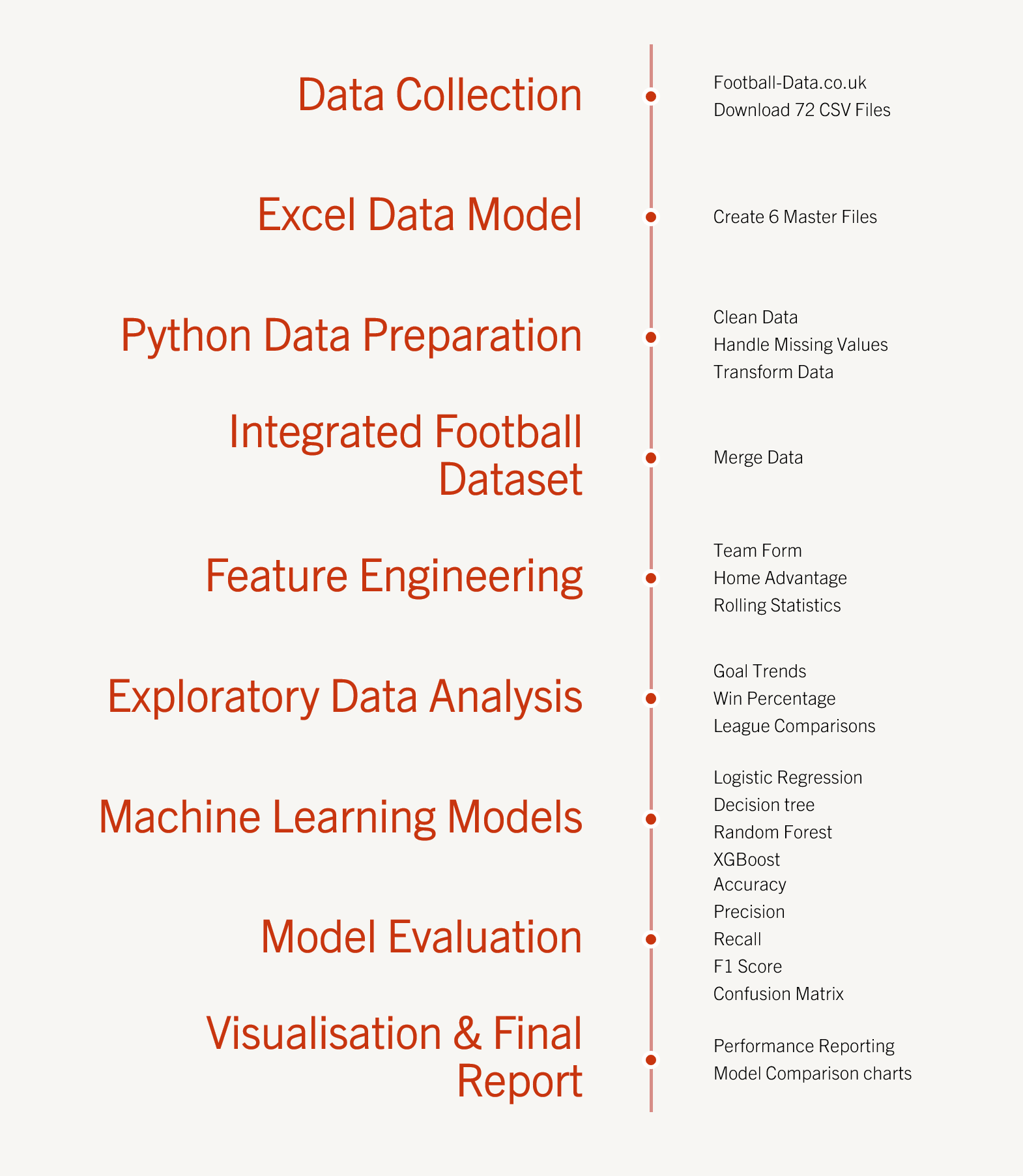
Figure 1 Methodology Gantt chart

Data Sources

The primary data source used for this project will be:
https://football-data.co.uk/data.php
This is a publicly available repository containing the required historical match statistics.
The data held within the csv files include important match data, such as, goals scored, shots on target, home goals, away goals and match results.
These variables will be relevant to the proposed business problem as they provide the information required for machine learning models to identify patterns associated with predicting football match outcomes.

Expected Deliverables

Project Timeline

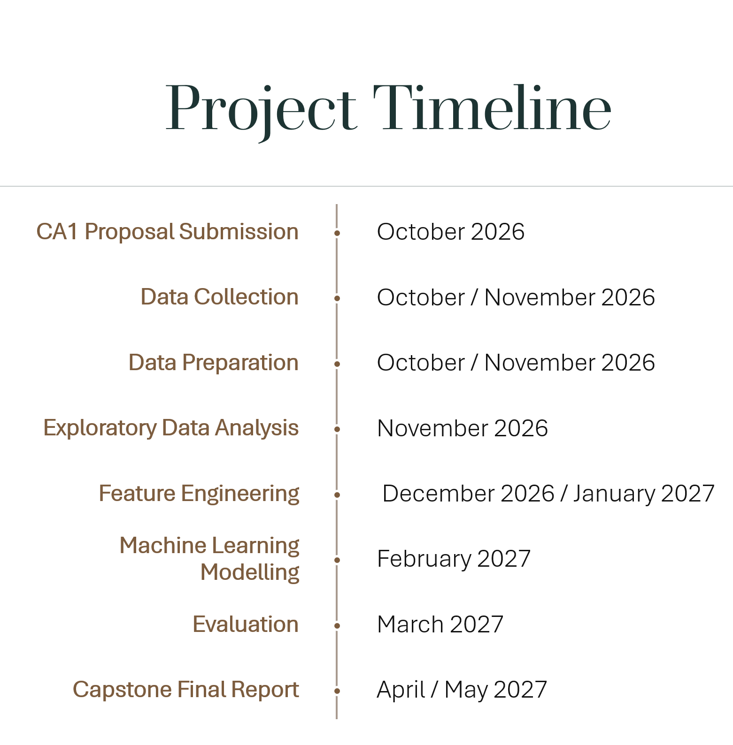
Figure 2 Proposed Project Timeline 2026-2027

Ethical and Legal Considerations

The data obtained for this project will be taken from:
https://football-data.co.uk/data
This site is a publicly available source of football match statistics. The dataset contains only historical football match information and does not contain personal or sensitive personal data.
This data will be used solely for educational and research purposes and no GDPR or privacy concerns are anticipated.

References

Football-Data.co.uk (2026) Football Results and Betting Data. Available at:
https://football-data.co.uk/data (accessed: 1 October 2026)

CCT College Dublin (2026) Strategic Thinking Module Notes. Available via Moodle
(Accessed (2 October 2026)
CCT College Dublin (2026) Data Preparation Module Notes. Available via Moodle
(Accessed: 25 September 2026)
CCT College Dublin (2026) Statistical Techniques Module Notes. Available via Moodle (Accessed: 24 September 2026)
CCT College Dublin (2026) Machine Learning Module Notes. Available via Moodle
(Accessed: 1 October 2026)
Python for Machine Learning & Data Science Masterclass By Perian Data. Available at: www.udemy.com
(Accessed: 8 October 2026)

